Installing nginx and deploying a index.html with playbook yaml files.

Nginx.yaml file
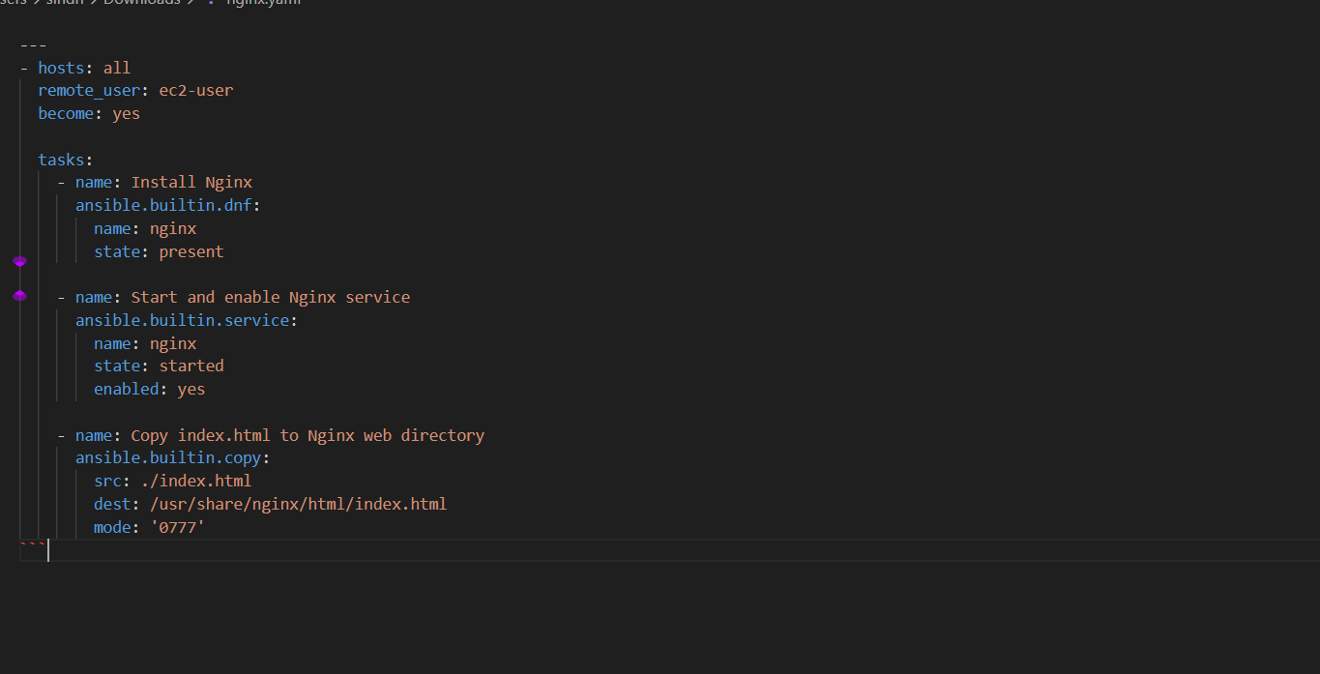
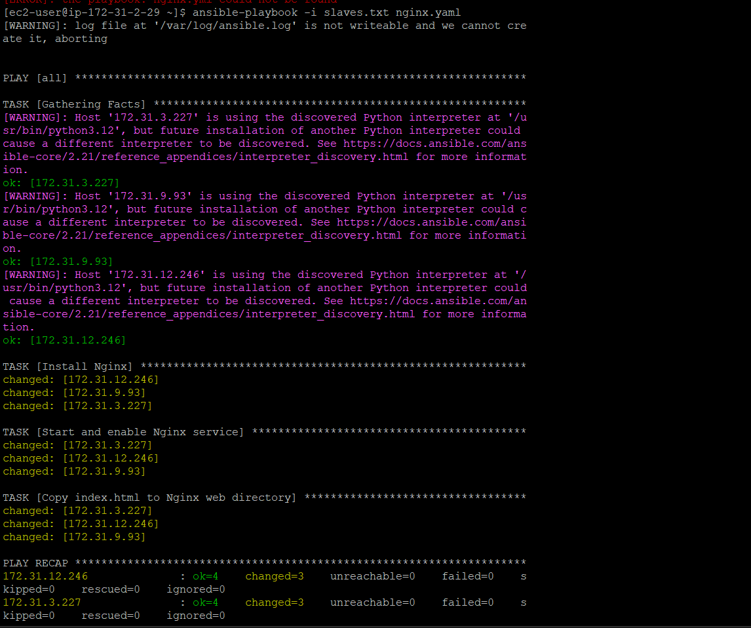
Now we check all three slave machines if the index.html works
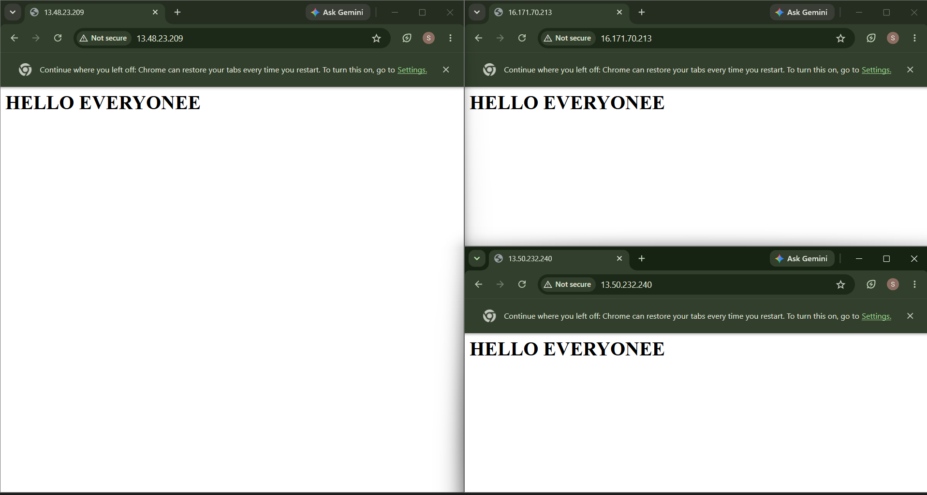
Using the playbook , we installed nginx and deployed a html file in all three slave machines

